



**CU6054NI**

**report**

**individual coursework**

**2024-25 Autumn**

**Student Name: Ritesh Paudel**

**London Met ID: 22068806**

**College ID: NP01MM4A220140**

**Assignment Due Date: Wednesday, May 7, 2025**

**Assignment Submission Date: Wednesday, May 7, 2025**

**Word Count: 2422**

**Project File Links:**

|  |  |
| --- | --- |
| **YouTube Link:** | [**https://youtu.be/aZ5Z4oK-rzY**](https://youtu.be/aZ5Z4oK-rzY) |
| **Google Drive Link:** | [digital media project](https://islingtoncollegeedunp-my.sharepoint.com/:f:/g/personal/np01mm4a220140_islingtoncollege_edu_np/Elc-nv-eDFJBkz0r3CldAi8BHm-09rDKc_h5EB4joG_Kjw?e=9GznQN) |
| **github** | [**https://github.com/riitesh10/DMP-Sakura-Busticketing--Luxury-Travel-Experience-.git**](https://github.com/riitesh10/DMP-Sakura-Busticketing--Luxury-Travel-Experience-.git) |

# Abstract

This project is about creating a 1 Minute Promo for Sakura Holidays, the best Bus Tour service in Nepal. The video seeks to increase awareness of the brand and it's services to attract new passengers by the virtue of a premium service.

There's a focus on the luxury 2/1 elite-class seats on the buses - giving passengers some added support while they travel, and information on the revolutionary butane gas heating system in the vehicles, part of a long line of vehicles that provide a comfortable mean of travel in all sorts of weather. “To stay informed how far the bus is to you in real time, you can use the real time tracking feature.” The commercial also promotes ease tracking the bus. The video also displays just how easy it is to book tickets with the Sakura Holidays app and website, as well as secure payment modes like eSewa, Khalti, mobile banking, and MasterCard, putting customers’ minds at ease during bookings.

There were months of pre-production on the project where I wrote a comprehensive script and roughed out the entire storyboard to get the message right and the edit right. Whilst on the shoot, B roll was taken to showcase the luxury and convenience of the service. For post-production, the team employed Adobe Premiere Pro for video editing, as well as Canva to create a video with dynamic motion graphics that show off features like the booking process and real-time tracking.

The key objective of this video is to establish Sakura Holidays as the number 1 preference for travellers in Nepal.It effectively delivers the message of how comfortable and convenient it is to use their services, ensuring the consumers that it’s an effort to achieve 100% customer satisfaction using modern technology and payment systems by the company. This is with a view to raising awareness for the brand and attracting more people to use Sakura Holidays for all their travel needs.

# Introduction

* 1. topic

Introduction This report is written to develop an advertisement for Sakura Holidays, advertising their new luxurious 2x1 elite-class coach seats as well as their easy to use online booking system. The ad was created to showcase the ease, comfort and creativity behind a Sakura Holiday. It was shot on a Sony A7III (which has a reputation for beautiful image production) and edited in Adobe Premiere Pro and Canva. Canva motion graphics were used to promote key benefits like real-time booking and secure payment system, ensuring a contemporary visual experience for viewers.

Taking cues from top travel sites such as RedBus and TripAdvisor, the video aims to achieve an increased brand saliency and more customers. This was a client driven project which called for extensive pre-production and a production day that would lead to a heavily edited and post-produced video in line with the client - Sakura Holidays marketing vision. ‘Premium’ approach to perception Our closing advertisement was designed to promote the company as a premium travel provider, as well as appealing to those more upscale holiday travelers, and to get the brand at the forefront of the potential customer’s mind.

# Area of Research

To cut an impressive ad spot for Sakura Holidays, the project team delved deep on top-performing travel brands like TripAdvisor and RedBus. These are brands that have utilized cinematic visuals, motion graphics, and targeted messaging to tell the story about what they do. Data from those platforms drove the ad concept to make it aesthetically pleasing, yet also informative, to the desired demographic.

The ad really gets to the heart of unique aspects of Sakura Holidays that make it different from others:

* Thailand-Imported 2×1 Luxury Seats: The commercial focuses on the incomparable comfort and luxury of the imported seats, placing Sakura Holidays as the premium offering for travel within Nepal.
* Live Tracking and Online Booking: Showcasing the latest and user-friendly real-time bus tracking and online booking through the app and website.
* Secure Payment Options: In combination with the acceptable payment types - eSewa, Khalti, and CardPay, the brand has further accentuated the need to adhere to customer safety and convenience.
* The target audience for the ad is intended to be the two destinations in Nepal – Lumbini and Pokhara - people travel to the most. This guest was selected for the present day, and techy wanderlust travellers who appreciate luxury and ease of travel on the move. Through its clean illustrations and 2D animation, the ad depicted how simple and life-saving the services are, simplifying the difficult characteristics to make them more comprehensible. In addition to all this, professional filming methods were also incorporated such as smooth camera rides, careful “make up” with lighting and everything that could make the commercial exciting to viewers.
* Mixing rich images and targeted messages, the advertisement sought to reinforce Sakura Holidays' place in the market as the preferred, top-notch choice for the contemporary traveler in search of ease, comfort, or hassle-free travel activities.

# Aim of Project

The objective of this project is to create a premium quality promotional video for SAKURA HOLIDAYS, luxury tourist bus service of Nepal. The video aims to:

Highlight features: 2x1 Eliteclass seats, real-time tracking, digital booking through app as well as website

Mention safe payments: eSewa, Khalti, Mobile Banking and Mastercard to be supported

Develop core routes: Pokhara and Lumbini - popular for both domestic and international tourists.

Create brand identity: Represent Sakura Holidays as a high-quality, reliable, and contemporary travel company

Leverage multimedia skills: Apply motion graphics, video editing, and cinematic storytelling visuals (Adobe Premiere Pro, After Effects)

Target audience 18-50 year old travellersEngagement:Younger travellers were targeted with stories, images and music.

Ultimately, the project will work towards raising brand awareness, have the guests to trust it more and convert more bookings.

# Target Audience

The Sakura Holidays ad caters to holidaymakers who do not want to compromise on luxury as they travel from one popular destination in Nepal to another.

**Age Group:**

Youth up to age 80 including working professionals, families, and travel lovers.

**Location:**

Concentrate on key travel corridors: Kathmandu, Pokhara, Lumbini, and Bhairahawa.

Also attractive to foreign tourists, particularly those who are visiting Lumbini (the birthplace of Buddha) and Pokhara (Nepal’s tourism capital).

**Gender:**

Inclusive of all genders.

**Interests & Needs:**

Individuals who value:

Luxury, comfort, and safety

Real-time bus tracking

Easy mobile/online booking

The video content is-designed lifestyle choices, to the expectations and to the digital behavior of the travelers today.

1. Product Research Summary

For the advert of Sakura Holidays, we researched top qualities that today's tourist looks for:

Comfortable setting: Stressed the space of the elite 2x1 seating.

LIVE BUS TRACKING: Something was made live on the screen through motion GFX.

Online/Mobile Booking: Spoke to how easy it is to book on the app and website.

Safe Payment Modes: An account with eSewa, Khalti, mobile banking or Mastercard is necessary.

On Time Service & Courtesy; Promoted service as on time and customer friendly.

Taking a cue from the likes of RedBus and TripAdvisor, the ad used simplistic story telling and motion graphics to bring the features to life.

# Technologies Used

The footage was edited using Adobe Premiere Pro for the Sakura Holidays ad. This involved cutting clips to create a seamless flowing video and colour correction to give it the right look, as well as the adding the relevant text overlays such as ‘Real time tracking’ and ‘Elite 2x1 seating’ are some of these overlays among others that we added to showoff the features. We included a scene transition to maintain the flow of the video naturally and professionally.

To liven up the video a little more and provide extra information animation was created; this was done in Canva Pro. These animations showcased important features such as how to book utilising the app, secure online payment icons and live bus tracking. This made the ad easy to see for all the viewers and felt in the digital modern line up of Sakura holidays.

Mixing professional editing with clean helpful graphics, the final video was stylish, informative, and all wrapped around the brand to draw in tech savvy and comfort seeking travelers.

1. **Project plan**

**Revised production timeline and adjustment**

**Intial vs final execution**

The project was delayed for the model not being available, thus the new completion date. After the meeting, I continued shooting when the model was ready and did other tasks in between that were part of staying on schedule

**New Timeline Adjustments**

**Pre-Production Derailed (Feb – Mid April)**

More time was needed for the:

* Recheck availability of model, Sandhya Niroula?
* Give you up to go back to location permissions (home - apartment, bus stop, bus inside)
* Redraw storyboard and script according to modified schedule

**Production Moved to Late April**

* Rescheduled photo shoot and finished it twice (1 Week vs 3 Days)
* Close adherence to shot list done in single take due to time restrictions

**Fast Forward (Late April/Early May)**

* All editing and motion graphics done within 1 week
* Effects and transitions simplified to speed up the export
* Color correction, matched new lighting from re-scheduled shoot

**Gant chart previous and new comparison**

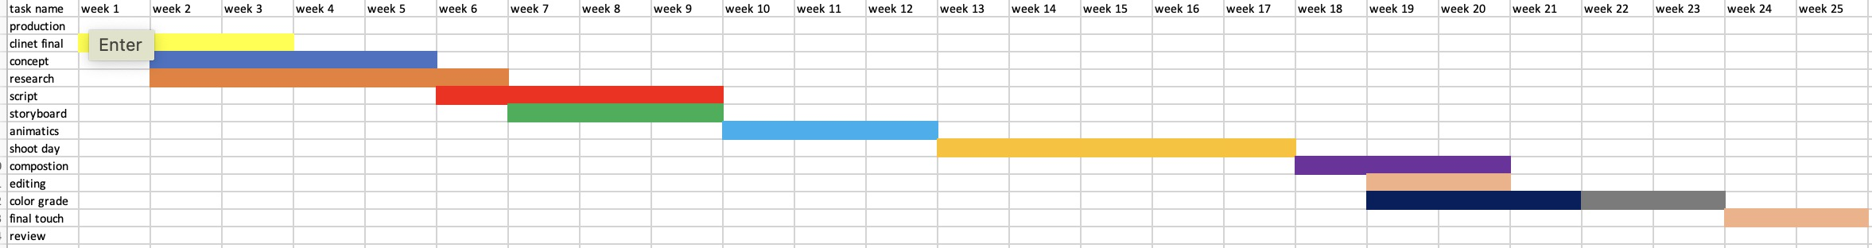

1. **Production phase**

Production Phases (in brief) - Sakura Holidays Commercial

Pre-Production Phase

Concept research: RedBus, TripAdvisor-inspired who want premium feel and convenience.

Script & Storyboard: To involve non-verbal story telling with much close-up on the elite class seats and the booking app.

Casting:Sandhya was chosen for her corporate look, which is in line with the brand's professional image.

Location Scouting: Selected a peaceful and calm apartment for the App booking scene and the inside of a bus to highlight the high class experience.

**Production Phase**

**Objective:**Make sure the commercial is shot exactly.

**Key Steps**:

Produced a comprehensive call sheet for crew and equipment required.

Captured the luxury lifestyle with solid lighting, steady camera movements and creative direction on set.

Worked directly with the rest of the team to ensure smooth implementation.

**Post-Production Phase**

**Editing:** Clips were cut together tightly, with some background music to lend a chill vibe.

**Motion Graphics & VFX**: Boosted the bookings and app interface.

**Color grade**: To give the luxurious, modern feel to the image.

**Output:** Delivered final render in social media friendly files.

# Resources planning

Sakura Holidays Commercial Making-of: Hardware & Software Used For Making the

**Sakura Holidays Commercial: Hardware & Software**

**Production Hardware (Filming Gear)**

**Primary Tools (As Planned):**

A7III (for full quality video capture)

Gimbal (for your smooth, stable shots)

Monopod (for when you just need something akin to a stick with a camera on the end for a low shot, but don’t want a low shot that ends with your finger’s in the film)

LED Panels/Soft Boxes (to direct light and give expensive look)

LCD for Framing & Focus Checking on Set

Batteries and Storage (additional SD cards and power backup for longer shoot days

a. **Post-Production for Sakura Holidays**

Editing (Adobe Premiere Pro):

The segments were cut for pace, and a lush bed of background music to set the tone of luxury.

MotionGraphics (canva ):

Graphics emphasized its process for making reservations on the app.

**Color Grading:**

Whitened whites and deeper blacks for that clean look!

**Final Output:**

The commercial was designed for digital platforms and was social media and online and marketing ready.

**9. User testing and finding**

A. Smartphones

* Tested Sizes: 6″-6.7″ (Additional options for iPhones, Samsung phones)

**Findings:**

* No cropping or quality loss
* Text and logo were clear
* App demo was easy to see

**B. Tablets**

* Tested Sizes: 7"–12.9"

**Findings:**

* Little black bars on the iPad 4:3 but everything played back very well.
* Colorspopped on high-res screens

**C. Laptops & Desktops**

**Tested Resolutions**:

* Full HD (1920 x 1080), QHD, Ultrawide

**Findings:**

* No distortion
* Flawless 4K viewing with decent hardware
* Cinematic on ultrawide monitors
* D. Smart TVs
* Tested in 1080p and 4K

**Findings:**

* Played smoothly
* Contrast was great, too details (such as seat textures) were clearly defined.
* No buffering on YouTube
* Performance & File Format

**User Feedback (13 people** )

* 8/10 loved the clean, smooth feel
* Some preferred more measured app switches
* Brand and sitting just stuck with everyone
* Played well on 4G and Wi-Fi

**Changes Made:**

* Slowed down app scenes
* It looks or even on seat shots!
* Condensed intro for immediate effect

# Conclusion

Producing this Sakura Holidays commercial has been an amazing experience.Working on this ad has been truly inspiring, we had the opportunity to experiment and learn so much not only from a creative point of view but also from the technical side of the production. I learned about the whole video production life circle from concept, script writing, shooting and cut editing, to the final compress for release.

I was also able to further polish my low level motion graphics skills, such as in Canva, where I created custom animations and transitions to boost the ads aesthetic. I have also become more skillful with adobe premiere pro, which was central in editing the video and making it look professional. I had the opportunity to get my hands on professional filming gear such as the Sony A7III and gimbal, and learned how to shoot smooth, good footage on those.

Aside from the technical, the project certrainly taught me some important real world skills, namely problem solving and project management. Multiple problems scheduling, location, and working with the team popped up, but these experiences taught me how to deal with the complications of a real production environment. I discovered how to manage the pressure, improvise on the fly and to work with others to realise a creative vision.

All in all this project was a brilliant and worthwhile project as a multimedia student, as not only did I gain the technical skills, but the real life feel and challenge of the production of a commercial. It was a fantastic challenge to apply all I’ve learned to date and force me to problem solve, think creatively, and effectively in order to hit a professional standard and give the client the results they dreamt of.

# 10.References

Vidico. (2024). *25 Best Commercial Ads of All Time (2024)*. [online] Available at: <https://vidico.com/news/best-commercial-ads/>.

‌Decker, A. (2019). *The Ultimate Guide to Branding in 2020*. [online] Hubspot.com. Available at: <https://blog.hubspot.com/marketing/branding>.

‌Sakura Holidays (2024). *Sakura Holidays | Bhairahawa Kathmandu Tourist Bus*. [online] Sakura Holidays. Available at: https://www.sakuraholidays.com.np/about/ [Accessed 6 May 2025].

‌Indeed Career Guide. (n.d.). *14 Pieces of Videography Equipment For the Beginner Filmmaker*. [online] Available at: <https://www.indeed.com/career-advice/career-development/videography-equipment>.

Indeed Career Guide. (2024). *14 Helpful Topics for Team Meetings at Work (With Tips)*. [online] Available at: https://www.indeed.com/career-advice/career-development/topics-for-team-meetings-at-work.

Davis, E. (2022). *12 Creative Examples of Bus Advertising  - Jungle Communications*. [online] Jungle Communications. Available at: https://www.junglecommunications.com/12-creative-examples-of-bus-advertising/ [Accessed 6 May 2025].

‌

# 11. Bibliography

Youtu.be. (2025). Available at: https://youtu.be/fD23F0jlTEU?si=ir7dm10C4wA6M9OI [Accessed 6 May 2025].

Youtu.be. (2025). Available at: https://youtu.be/JG-JmAbDs6M?si=XkZ905RE4g_GoruF [Accessed 6 May 2025].

‌Youtu.be. (2025). *Securly - Geolocation sharing*. [online] Available at: https://youtu.be/TH91r0Cj7bc?si=SsT4EFEgD_T2PCQQ [Accessed 6 May 2025].

‌Youtu.be. (2025). Available at: https://youtu.be/yxrNkJ_pHpQ?si=D1wDBk9CgWFAijnC [Accessed 6 May 2025].

‌Youtu.be. (2025). Available at: https://youtu.be/mrh3evE97-E?si=-Avp6XsxnKtUUPZd [Accessed 6 May 2025].

‌

# 12. Appendix

a. survey

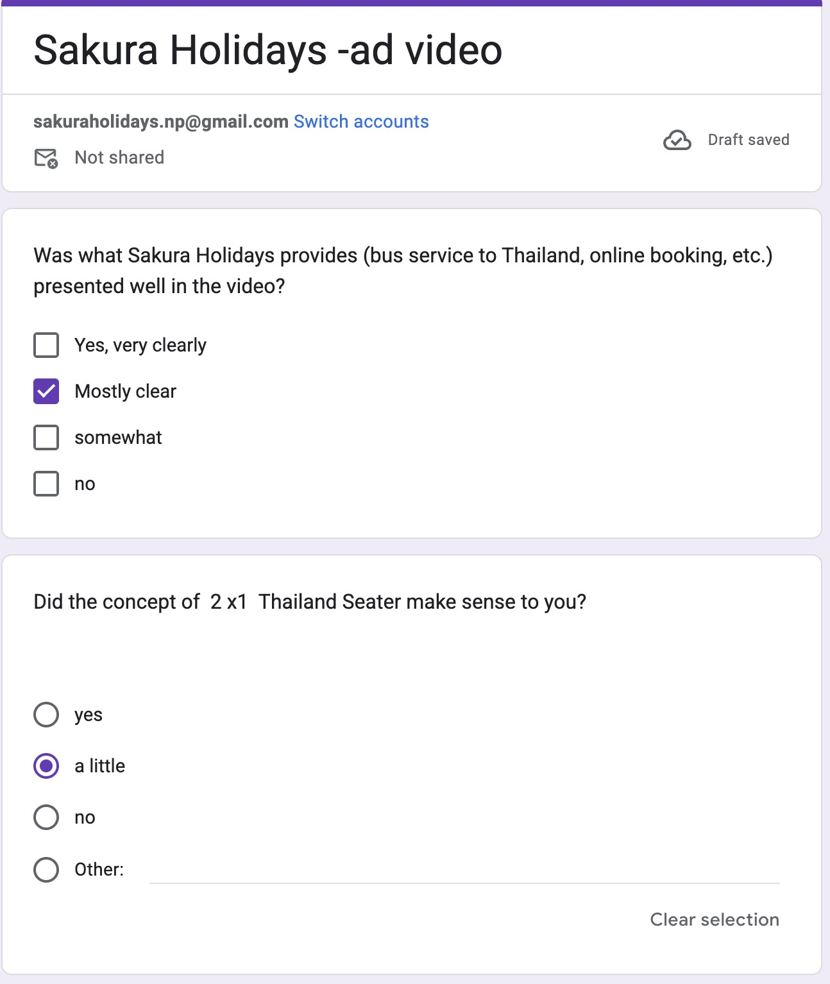

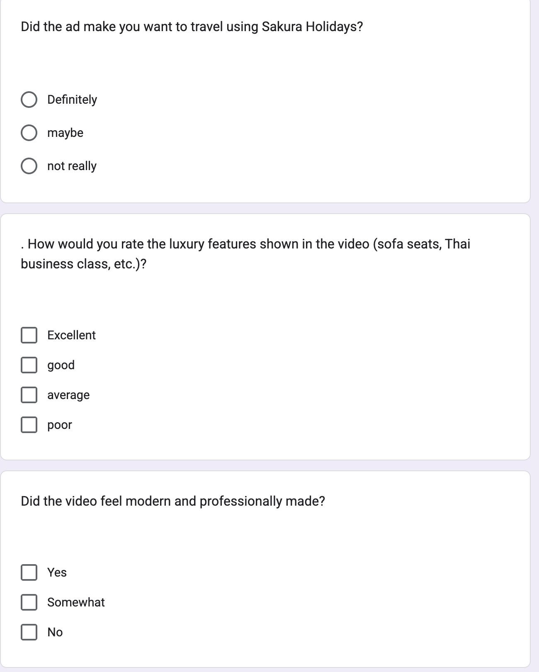

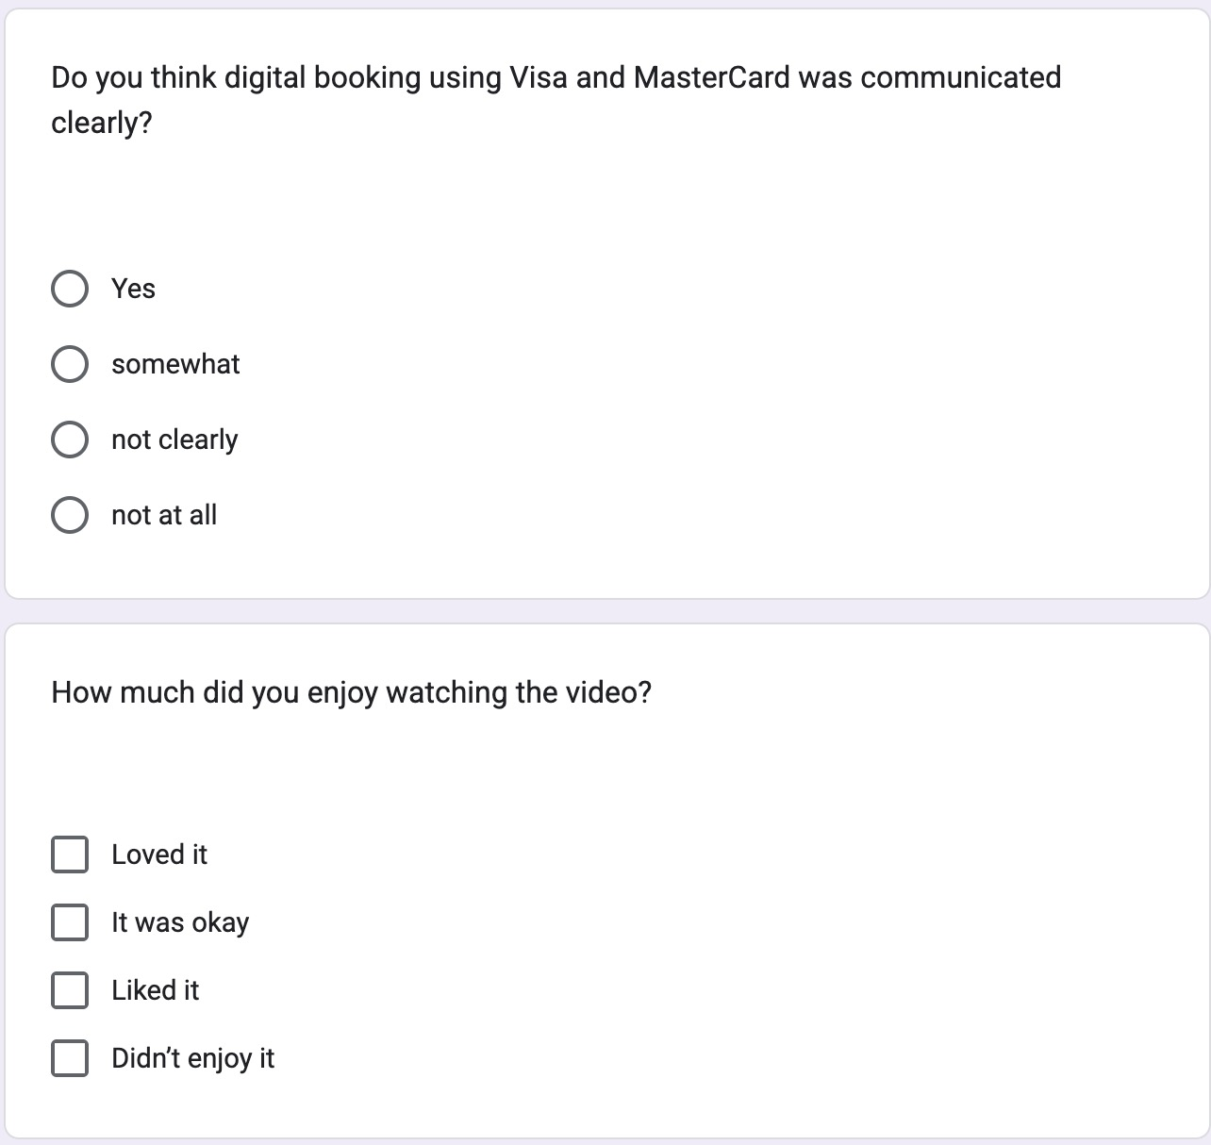

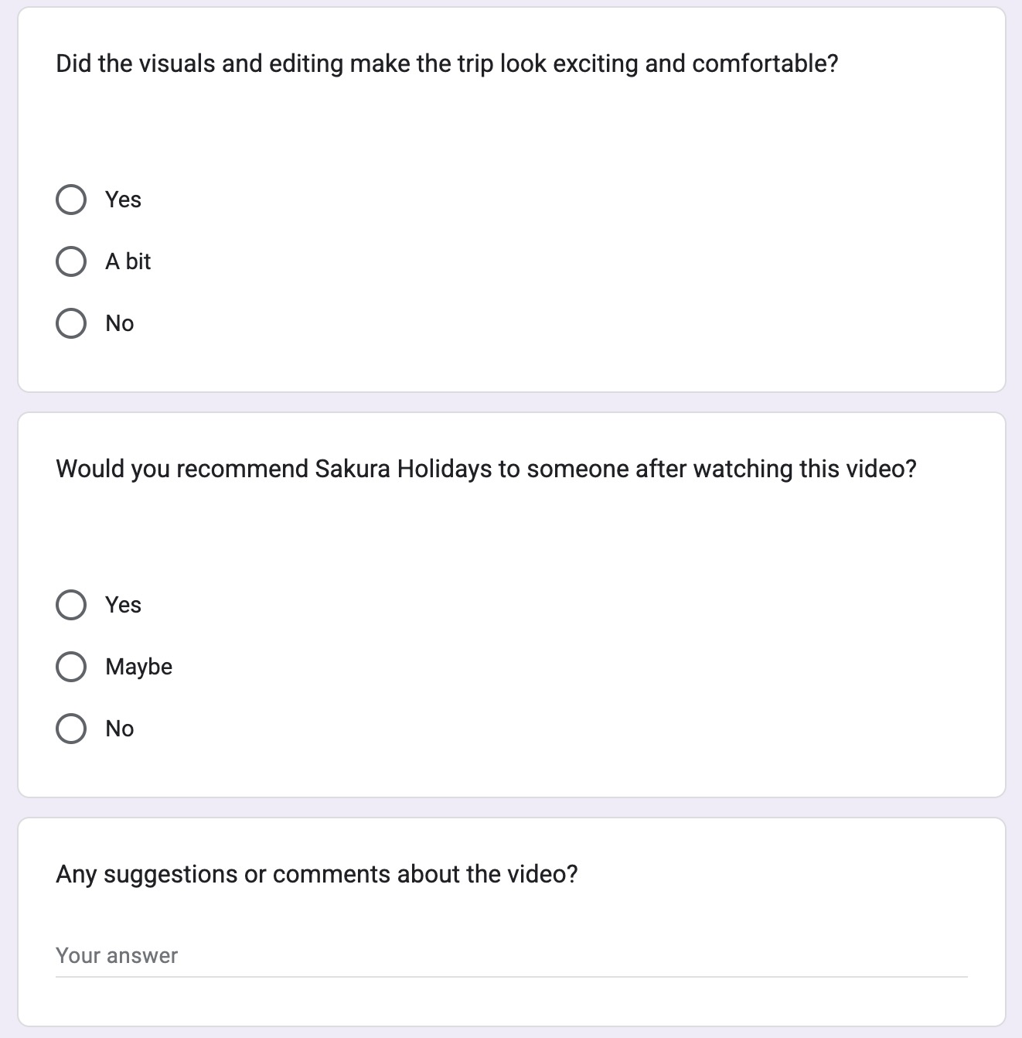

b. response

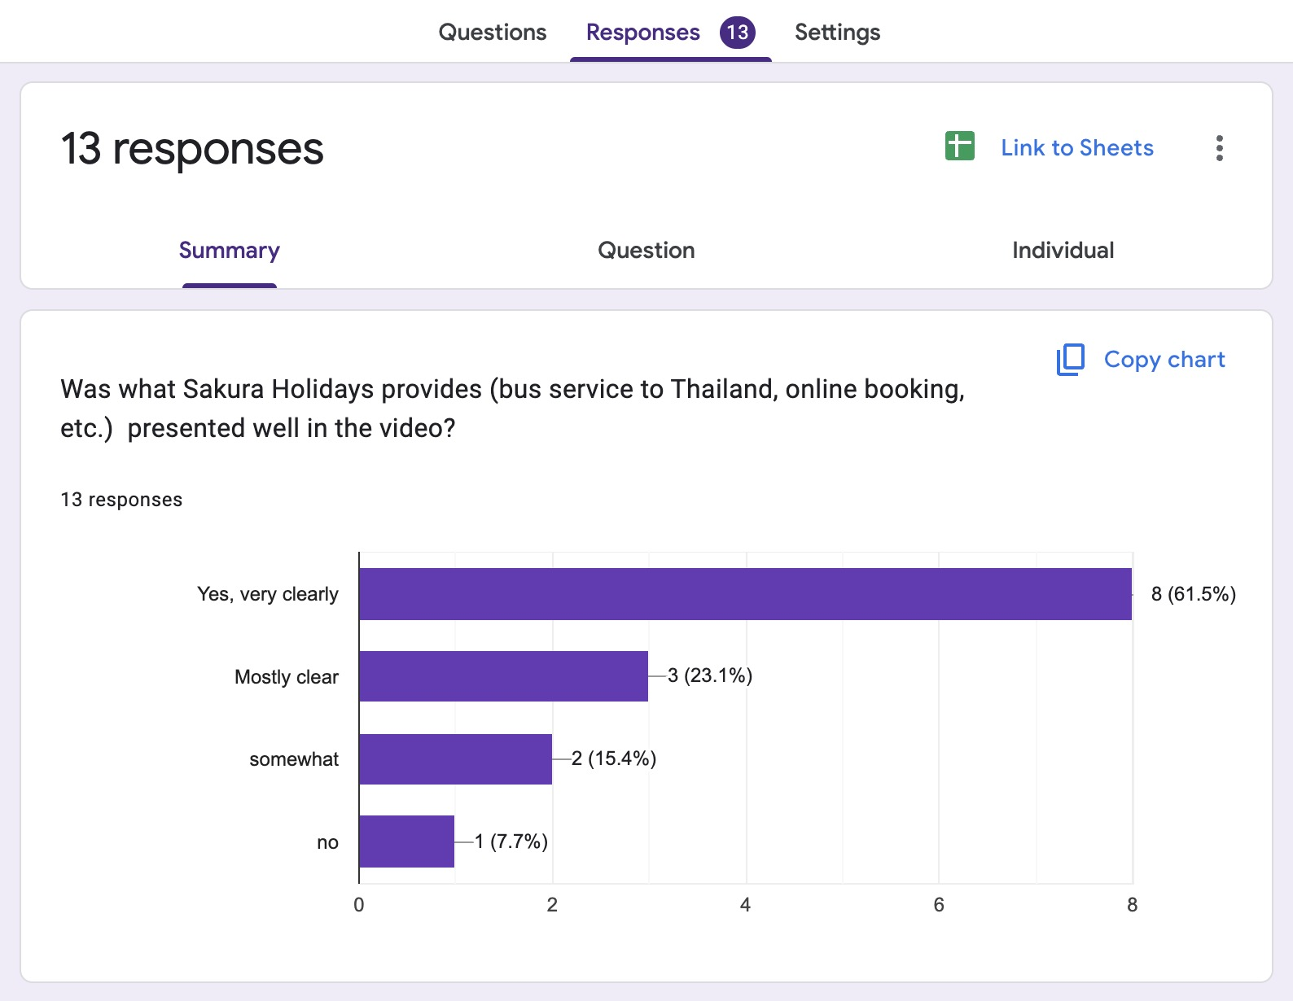

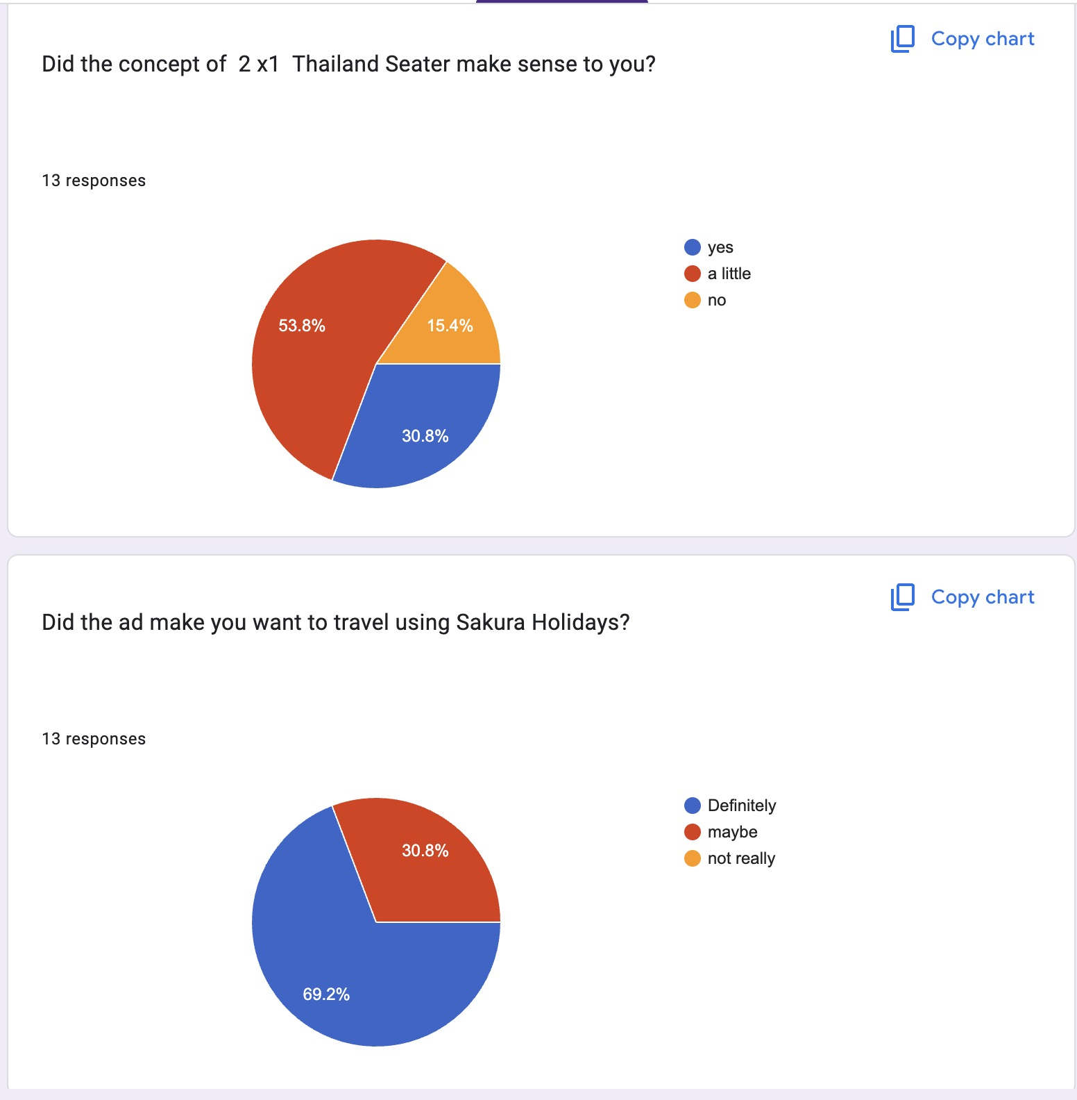

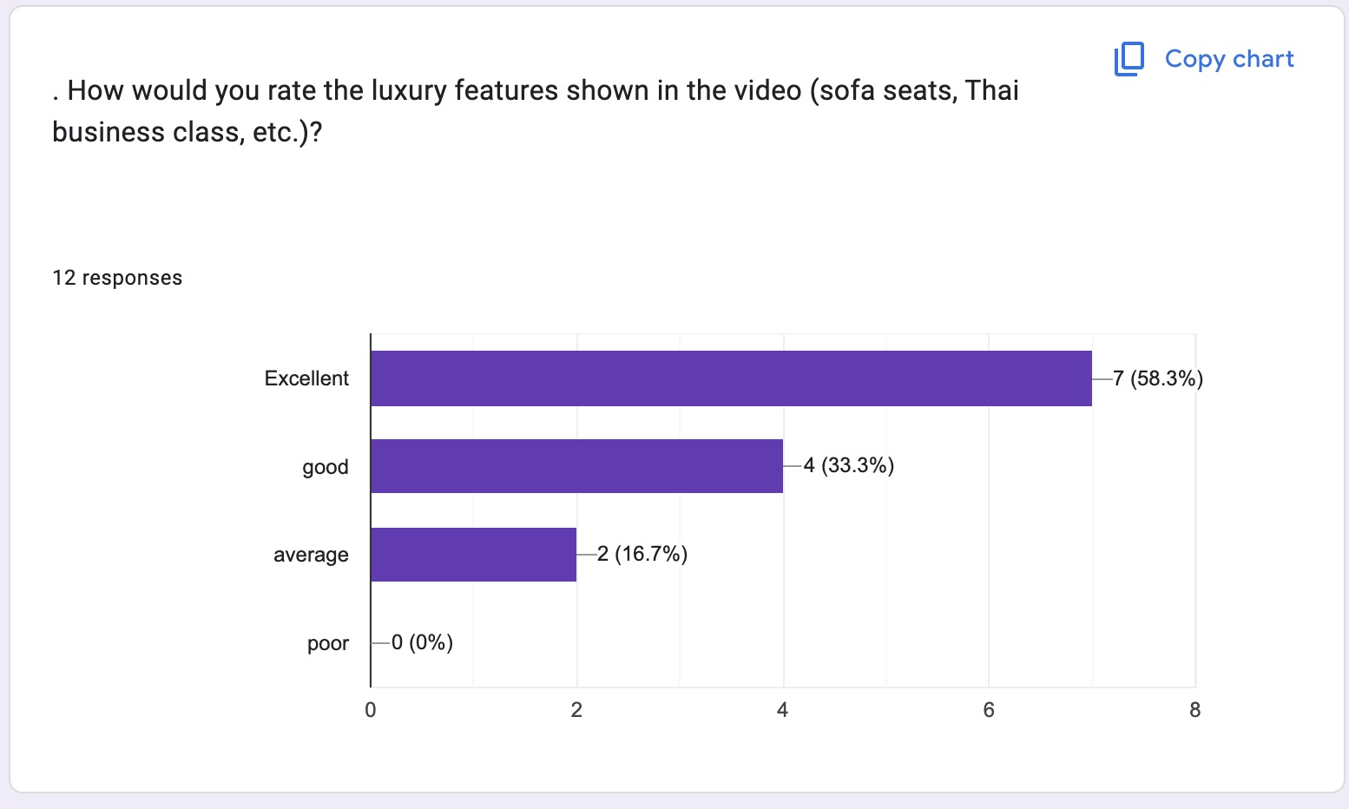

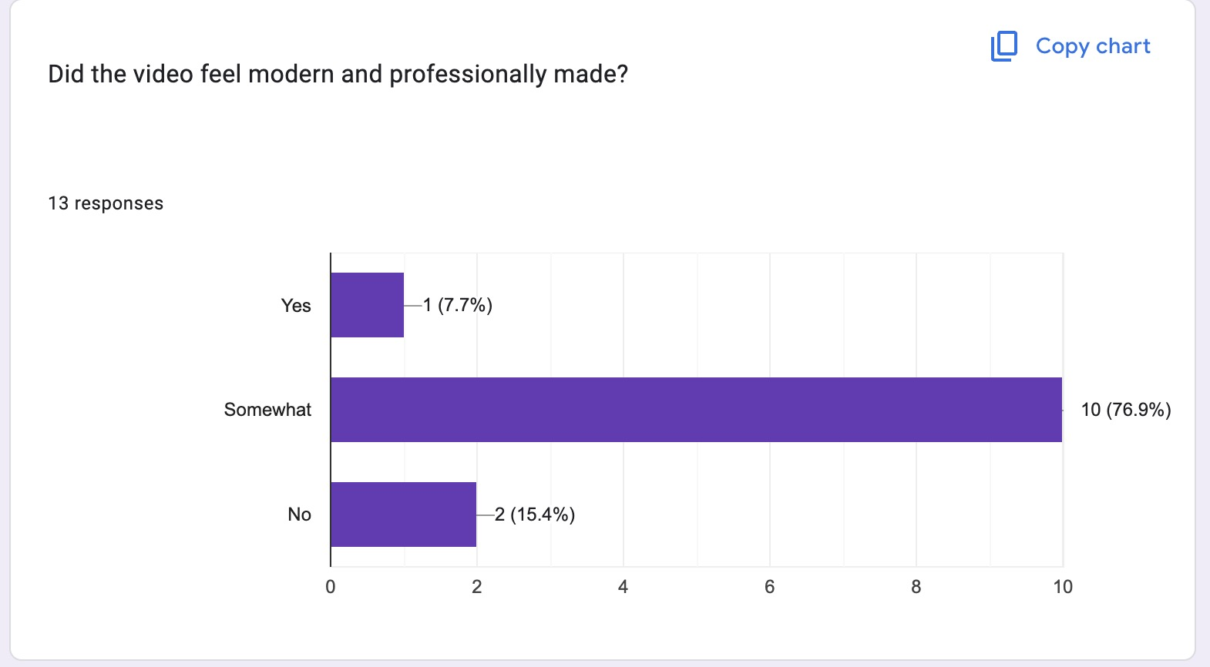

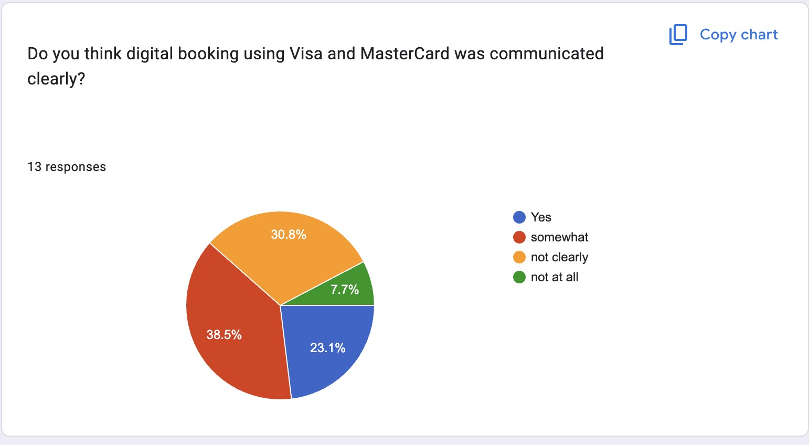

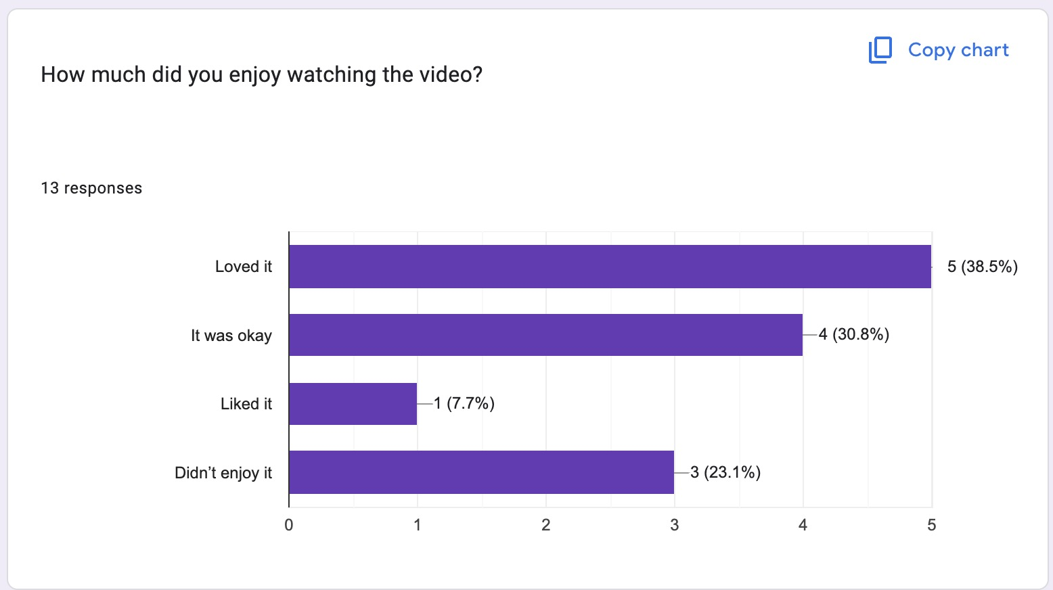

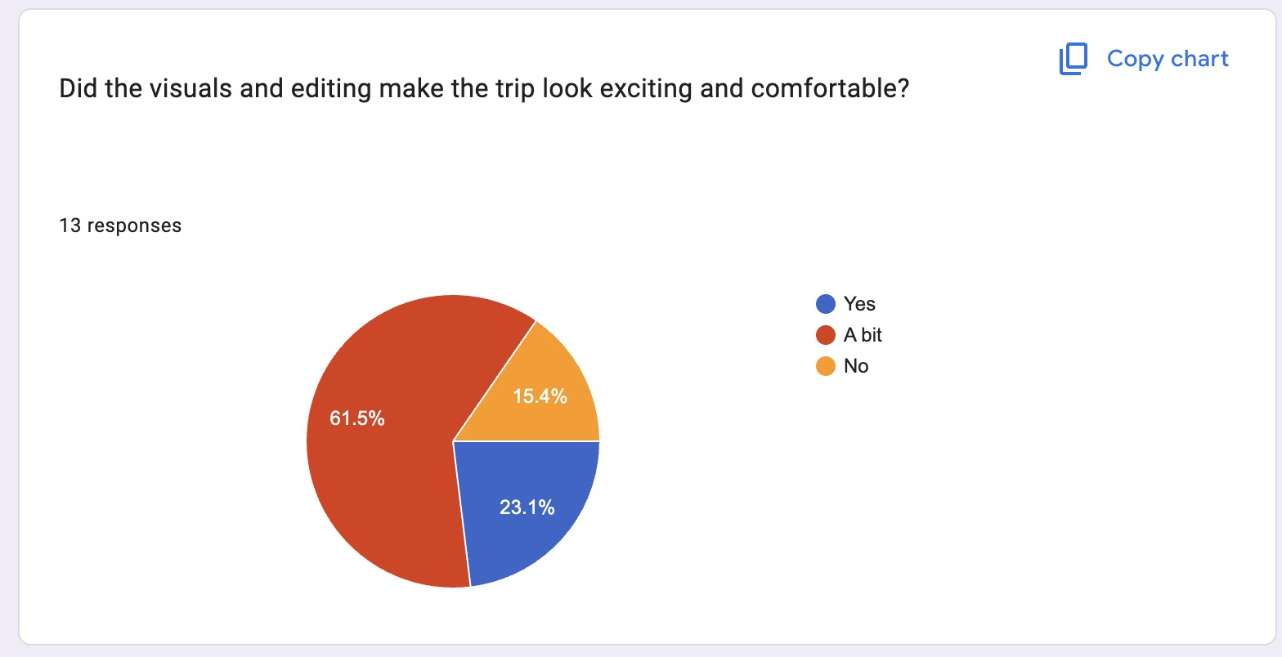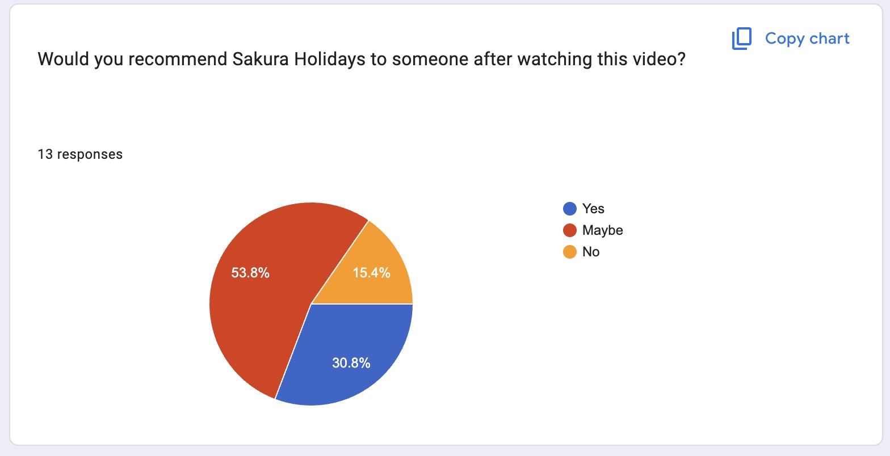

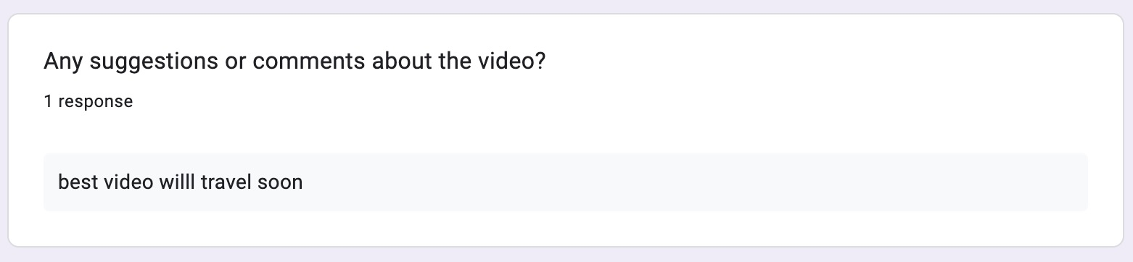

c. gant chart



d. logsheet

